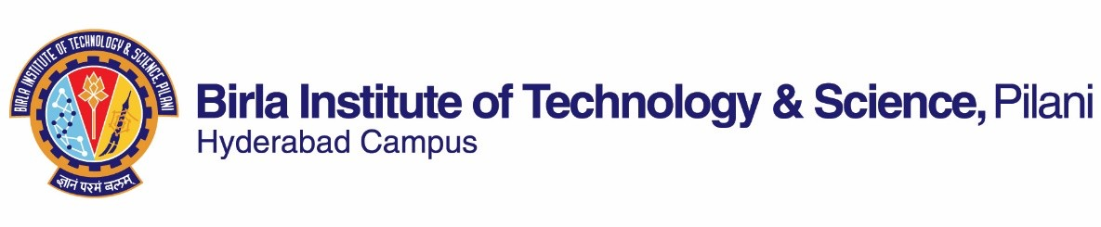

# FIRST SEMESTER 2023-2024

Course Handout Part II

Date: 11-08-2023

In addition to part-I (General Handout for all courses appended to the time table) this portion gives further specific details regarding the course.

*Course No.* : AN F313

*Course Title* : Flight Mechanics and Controls

*Instructor-in-Charge* : Dr. Jayaprakash K S

# Scope and Objective of the Course:

This course is on applied aerodynamics and modern approaches in aircraft stability and control. The focus is primarily on static stability and dynamic stability analysis, conditions of trim flight, physical effects of the wing, fuselage, and tail on aircraft stability and control. Classical and modern control techniques will be discussed with time and frequency domain analysis of control system performance.

Objectives

* To understand the basic concepts of equilibrium, static stability, and trim flight.
* To understand and study the linearized equations of motion of flight dynamics.
* To study the stability and control of aircraft during several maneuvers

# Textbooks:

1. Cook M. V., Flight Dynamics Principles, Elsevier Aerospace Engineering Series (2007) [TB]

# Reference books

1. David G. Hull, Fundamentals of airplane flight mechanics, Springer; 2007. [RB1]
2. Tewari A., Automatic control of atmospheric and space flight vehicles: Design and analysis with MATLAB and Simulink, Birkhauser, 2011 [RB2]
3. Robert C Nelson, Introduction to Flight Stability and Automatic Control, 2nd Edition, McgrawHill, 2017 [RB3]

# Course Plan:

|  |  |  |  |
| --- | --- | --- | --- |
| **Lecture No.** | **Learning objectives** | **Topics to be covered** | **Chapter in the Text Book** |
| 1-3 | Introduction | Flying and handling qualities, general considerations, atmosphere, aircraft equations  of motion, aerodynamic nomenclature | 1 |
| 4-15 | Static equilibrium and trim | Axes notations and transformations, Static stability and control: Definitions, longitudinal  static stability and control, trim conditions, | 2, 3 |

|  |  |  |  |
| --- | --- | --- | --- |
|  |  | directional control, rolling stability and control |  |
| 15-21 | Equations of motion and  solution techniques | Small perturbation theory: The equations of motion of a rigid symmetric aircraft, the linearized equations of motion, decoupling of  equations, aircraft response transfer function | 4, 5 |
| 21-33 | Longitudinal and lateral dynamics | The dynamic stability modes, reduced order  models, stick fixed motion, short period approximations, flying and handling qualities | 6, 7 |
| 33-42 | Aircraft control and other Miscellaneous topics | Aircraft’s response to control, Control theory: Routh’s criteria, Root-locus technique | 8 |

**Evaluation Scheme:**

|  |  |  |  |  |
| --- | --- | --- | --- | --- |
| **Component** | **Duration** | **Weightage (%)** | **Date & Time** | **Nature of**  **Component** |
| Quizzes# | 40 min | 20% | Unannounced | OB |
| Mid semester Test | 90 min | 25% | 09/10 - 11.30 - 1.00PM | CB |
| Seminar or assignment | 40 min | 15% | TBA | OB |
| Comprehensive Exam | 180 min | 40% | 06/12 AN | CB/OB (Hybrid) |

# Three unannounced quizzes will be conducted, and the two best scores will be taken for evaluation

**Chamber Consultation Hour:** Monday 5 pm to 6 pm. Other weekdays with prior appointment.

**Notices:** All notices concerning this course shall be displayed on the CMS (the Institute’s web-based course management system). Students are advised to regularly visit CMS for latest updates.

**Make-up Policy:** Make ups are not given as a routine. It is solely dependent upon the genuine medical or health circumstances with proper documentary evidence under which a student fails to appear in a scheduled evaluation component. In such circumstances, prior permission should be obtained from the Instructor-in-Charge (I/C). Students with less than 70% of attendance will not be allowed to avail the make-ups. The decision of the I/C in the above matter will be final.

**Academic Honesty and Integrity Policy**: Academic honesty and integrity are to be maintained by all the students throughout the semester. Any form of academic dishonesty would lead to serious actions.

# Dr. Jayaprakash K. S. INSTRUCTOR-IN-CHARGE